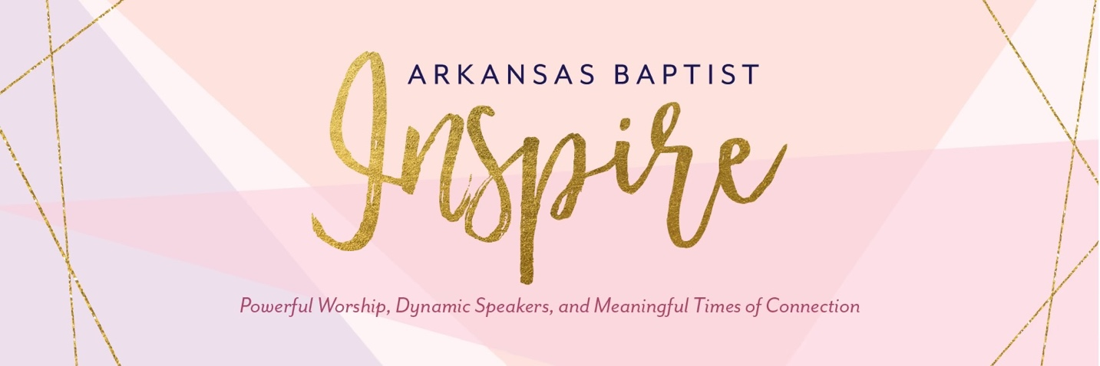

Arkansas Baptist Inspire is excited to partner with Deeper Still Arkansas for the Inspire 2023 ministry project! You can find a list of items we will be collecting for Deeper Still, as well as ways to partner with this ministry, at the end of this document. Collected items will be given to women going through abortion recovery retreats.

Deeper Still Mission
​
​The mission of Deeper Still is to multiply ministry teams to bring healing and lasting freedom to abortion-wounded hearts through weekend retreats and education.​
Deeper Still is a ministry of God’s mercy and healing power.
​God is ready to lavish His love and mercy upon this broken world. Through Deeper Still Retreats, we have come to realize the power of Christ-followers in community by reaching out to women who are still held captive by the guilt, shame, and grief of their past mistakes. The body of Christ has been left on this earth to bring the good news of salvation to the afflicted, to bind up the broken hearted, and to set the captive free.

Do you have an abortion wounded heart?
Our mission is to bring healing and lasting freedom to
men and women with abortion wounded hearts.
If you have experienced abortion,
we want you to know you are not alone.
We have been where you are.
We have walked in your shoes.
​We're here to walk with you on your journey of healing.

Understanding the Effects on Women
Guilt and shame are frequently at the top of the list when you ask women what symptoms they are experiencing from abortion.​ Praise God, freedom is available through Christ.

"I felt like a hamster on a wheel, striving to get closer to the Lord but never growing in relationship with Him. It was only when I completely surrendered my past hurt from my abortion, that He completely transformed my life! He had been pursuing me the whole time and wanted to heal all the pieces of my broken heart. At a Deeper Still retreat this past April, Jesus lovingly met me there!! He took away my shame and guilt and reminded me of my true identity….a daughter of the most high King. I am forever grateful!" - Jamie

Connect with Deeper Still Arkansas

Website: www.deeperstillarkansas.org

Ministry Project Items: The following items are utilized to provide a safe, comfortable, and beautiful place for men and women who attend a Deeper Still Arkansas weekend retreat. Many of the tangible items represent spiritual realities and are utilized throughout the weekend for healing. Thank you for donating any of these items to Deeper Still. Collection boxes will be located next to the entry doors at Inspire.
- Kleenex, rectangular or square size AND individual sized packages
- Christian décor to hang/sit around in each participant bath and bedroom. Any size is great!
- Small sized shampoo/creamer, lotion, soap, toothbrushes and small toothpaste, emery boards, and Chapstick to place in each participants bathroom.
- Throws (blankets) for participants to use in the large group room.
- Bears (about 15 inches; brown, white, beige, black, grey; no writing on them anywhere, i.e. Date, happy valentines, etc).
- Artificial Acorns (about 1 inch sized), Hobby Lobby has these.
- Votive candles with holders (simple ones are great) – used for a memorial service.
- Stuffed elephants.
- Simple musical instruments (tambourines, maracas, kazoos, etc.). We need more!
- White or grey towel, washcloth, and hand towel sets (a set is provided for each participant to use during the retreat).
- Hand Sanitizer (small, individual sized).
- Individually wrapped candy (chocolates, mints) and individual packages of gum.
- Magnetic Bookmarks (the kind that clip over a page) with Christian sayings.
- Cards with Biblical sayings, comments. These are used for encouragement and celebration.
- Highlighters
- Manilla Envelops (for mailing application and confirmation packets)
- Blue, double-pocket folders with prongs

Non-Tangible Ways to Support Deeper Still Arkansas Ministry:
- We would LOVE to collaborate with your Sunday School/LifeGroup and/or church to assist with meeting special retreat needs. Some examples include:
  - Picking someone up at the airport and giving them a ride to the retreat venue so they don’t have to rent a car.
  - Providing homemade snacks for the team/participants during the retreat.
  - Making crafts that we utilize at each retreat (i.e. handmade cards, flower garland for each woman).
  - Providing flowers or other centerpieces for dining room tables.
- Come to the Annual Deeper Still Arkansas Training (February 9-10, 2024) at the Arkansas State Baptist Convention to learn more about the needs of those with abortion wounded hearts and about this ministry and how God’s transforming power brings healing and lasting freedom!
- Prayer Support
  - Prior to each retreat we ask individuals and groups to pray for the upcoming retreat and those involved. We send out a session-by-session description of what we are doing throughout each day along with specific prayer needs. Please sign up for this at the Deeper Still Arkansas Table located in the vendor area at the Inspire Conference.
  - Make this ministry a focal part of your women’s ministry or church life through committing to regularly pray for our Board and the ministries outreach to those suffering in silence in our churches.
- Invite us to come speak to your church and/or group! We have over 40 team members ready to share their personal testimony and the truth about God’s transforming, redeeming power, and love! Again, sign up at the conference table if you’re interested in knowing more!

